ỦY BAN NHÂN DÂN TP.HCM CỘNG HÒA XÃ HỘI CHỦ NGHĨA VIỆT NAM
TRƯỜNG CAO ĐẲNG LÝ TỰ TRỌNG TPHCM Độc lập – Tự do – Hạnh phúc
********** ******

PHIẾU TRẢ LỜI TRẮC NGHIỆM

Tên: ____________________________________ Đề thi số: 01
Lớp: ___________ Ngày thi: _____________

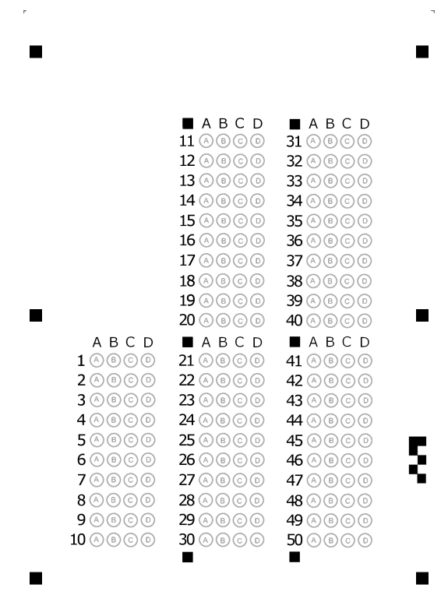

ỦY BAN NHÂN DÂN TP.HCM CỘNG HÒA XÃ HỘI CHỦ NGHĨA VIỆT NAM
TRƯỜNG CAO ĐẲNG LÝ TỰ TRỌNG TPHCM Độc lập – Tự do – Hạnh phúc
********** ******
ĐỀ THI GIỮA HỌC PHẦN LÝ THUYẾT
ĐỀ 1
BẬC ĐÀO TẠO : CAO ĐẲNG
HỌC PHẦN : ANH VĂN
HỌC KỲ : II NĂM HỌC: 2017 - 2018
Lớp: 17C1-NNA1, NNA2 Ngày thi: 16/ 04 / 2018
Thời gian thi : 60 phút
(Sinh viên không được sử dụng tài liệu trong khi làm bài. Sinh viên trả lời vào PHIẾU TRẢ LỜI TRẮC NGHIỆM)
(Đề thi gồm 40 câu. Mỗi câu trả lời đúng được 0.25 điểm)
------------------------------------------------
I. Match the letter A, B, C, or D to indicate the word or phrase that is CLOSET in meaning to the underlined part in each of the following questions
1. He dreams of visiting far-off lands
A. distant B. confident C. nearby D. analogy
2. For religious people, a wedding ceremony is sacred.
A. sanctuary B. progress C. holy D. fabric
3. Synthetic drugs are increasingly important for public health.
A. artificial B. eternal C. vanish D. exclusive
4. The soldiers were in a position vulnerable to attack by the enemy.
A. strong B. harmful C. exposed D. powerful
5. The governor received irate letters and phone calls from people who didn’t’ want higher taxes.
A. incensed B. ethical C. fitting D. mild
6. The computer has a number of important function.
A. conduct B. reputation C. purpose D. frail
7. Cargo is carried on ships, airplanes and trucks.
A. goods B. woods C. corporation D. institution
8. The teacher’s innocuous words don’t make me angry, but they don’t teach me much.
A. unsafe B. reckless C. harmless D. hazardous
9. The population is so dense here.
A. thin B. thick C. soar D. vacant
10. Salaries and associated costs have risen substantially.
A. isolated B. separated C. dismantled D. connected
II. Choose the best answer for the following sentences
11. The cost of your uniform will be ________ from your wage.
A. deducted B. detached C. deodorized D. departed
12. Kristin and Marcus disagree a lot, and they are very ________ of each other’s opinion.
A. conservative B. sacred C. critical D. tolerant
13. Some of the ________ tried to help the victims of the accident.
A. onlookers B. audience C. viewers D. spectators
14. This diet is ________ in vitamins.
A. inadequate B. deficient C. short D. insufficient
15. It is his ________ to become a famous singer.
A. fortune B. destiny C. chance D. opportunity
16. She studies many magazines and books about fashion, entertaining and correct social behaviour as she wants to appear ________.
A. fashionable B. elegant C. sophisticated D. artificial

17. A great number of people are ________ in environmental activities.
A. involved B. included C. related D. considered
18. What did you do to ________ their problem?
A. win B. control C. pass D. overcome
19. Why don’t you cut down all the ________ to make a path?
A. underdeveloped B. undergrowth C. undergone D. underground
20. Parents are responsible for the ________ of their children.
A. wealthy B. well-being C. welfare D. well-cared
III. Read the text and decide that each following statement is True or False
ANGKOR WAT
Visit Angkor Wat
Siem Reap is a small town near the world famous temple of Angkor Wat. The town is charming and worth exploring, with some fine examples of Khmer and French colonial architecture set among the more modern developments. Nowadays, visitors are flocking in, using it as a base for visits to the nearby temples.

A Carved City
From the 9th to the 14th centuries, when Europe was still struggling out of the Dark Ages, the Cambodian Empire of Angkor covered most of present-day Cambodia, Laos, Vietnam, and Thailand. The heart of this empire during the 12th century was the ancient capital of Angkor Thom, near present day Siem Reap, the site of the world’s largest temple complexes, which were rediscovered in 1861.This spectacular city was built over 30 years under the reign of King Suryavarman II (1113-1150). The area covers about 400 square kilometres and is full of the finest examples of Khmer art and architecture. Tourists are always amazed at the scale of the place.

In Angkor Wat you will find more than 100 stone monuments and temple buildings, each of which contains countless statues, sculptures and reliefs that have weathered extremely little over the last 800 years. To see the whole thing can take several days. The most important temples to visit in the area are Angkor Wat, especially at sunrise or sunset; Angkor Thom, the remains of the capital; Ta Prohm, a palace overgrown by jungle; and Bayon.

Getting a visa
Visas are required to enter Cambodia. You can obtain one on arrival at Siem Reap International Airport for $20, and 1 passport photo is required per person. You will also need another passport photo for the Angkor Temple Entrance Pass. Please ensure you take comfortable walking shoes, light clothing and plenty of water to drink as it is very hot there. The most commonly accepted currency in Cambodia is the US dollar.

21. Most people visit Siem Reap because of the temples in the area.
A. True B. False
22. Angkor Wat was the capital of the Cambodian empire.
A. True B. False
23. The stonework of Angkor Wat is in poor condition today.
A. True B. False
24. Dawn and dusk are particularly good times to visit Angkor Wat.
A. True B. False
25. You will need a couple of passport photos.
A. True B. False
IV. Below are descriptions of 6 camping grounds.
Adleigh Woods Park
Lovely surroundings in area of lakes and woods. Large camp with swimming pool, children's pool and playground. Camp café serves evening meals. Bookings Saturday to Saturday only. Phone 441 312326
Derston Gardens
One of the few camps to be found on a town centre. Quiet and private. No pets allowed. Popular with adults. Maximum 3 nights stay. Phone 441 231556
Grange Farm Camping Ground
Large quiet camp set in woods and close to river. (Suitable for experienced swimmers only.) 4 tennis courts. No playground. Self-service restaurant. Kitchens available for campers to cook own meals. Pets okay.
Highcliff Camp
Modern camping ground, popular with young people. Nightly discos and other entertainment included in price. Plenty of opportunities for water sports including sailing. No restaurant. Bookings weekend to weekend. Phone 441 536565
Kingswater Beach Park
Well-planned camp close to beach. TV room. Safe play area for small children. Excellent centre for touring. Frequent buses and trains to city. Phone 441 516435
Moorgate Park
Large camping area 2 kms. from town beside deep lake. (Dangerous for small children.) Good centre for fishing, sailing and waterskiing. Open-air countryside museum. Phone 319856.
Choose one camping ground for each group of people that best matches their interests.
26. Mr. and Mrs. Smith and their two young children will be travelling by train. They want to arrive on Wednesday and camp for three nights.
A. Grange Farm Camping Ground C. Adleigh Woods Park
B. Kingswater Beach Park D. Highcliff Camp
27. The Andertons and their grown-up children want somewhere they can do water sports. Their holiday will begin on Tuesday.
A. Adleigh Woods Park C. Highcliff Camp
B. Moorgate Park D. Grange Farm Camping Ground
28. The Baxter family want to start their holiday this weekend and stay at a camp where they don't have to cook for themselves at night. The children want to learn to swim.
A. Adleigh Woods Park C. Highcliff Camp
B. Grange Farm Camping Ground D. Derston Gardens
29. Jean and her friends have just left school and they want to camp where they can swim during the day and enjoy themselves in the evening at no extra cost.
A. Grange Farm Camping Ground C. Moorgate Park
B. Adleigh Woods Park D. Highcliff Camp
30. Mrs. Eldon and her sister would like somewhere out of town where there won't be lots of children, and where she can take her dog.
A. Adleigh Woods Park C. Grange Farm Camping Ground
B. Moorgate Park D. Kingswater Beach Park
V. Read the text and questions below.
For each question, mark the correct letter A, B, C or D.
As the twentieth century began, the importance of formal education in the United States increased. The frontier had mostly disappeared and by 1910 most Americans lived in towns and cities. Industrialization and the bureaucratization of economic life combined with a new emphasis upon credentials and expertise to make schooling increasingly important for economic and social mobility. Increasingly, too, schools were viewed as the most important means of integrating immigrants into American society.
The arrival of a great wave of southern and eastern European immigrants at the turn of the century coincided with and contributed to an enormous expansion of formal schooling. By 1920 schooling to age fourteen or beyond was compulsory in most states, and the school year was greatly lengthened. Kindergartens, vacation schools, extracurricular activities, and vocational education and counseling extended the influence of public schools over the lives of students, many of whom in the larger industrial cities were the children of immigrants. Classes for adult immigrants were sponsored by public schools, corporations, unions, churches, settlement houses, and other agencies.
Reformers early in the twentieth century suggested that education programs should suit the needs of specific populations. Immigrant women were once such population. Schools tried to educate young women so they could occupy productive places in the urban industria economy, and one place many educators considered appropriate for women was the home.
Although looking after the house and family was familiar to immigrant women, American education gave homemaking a new definition. In preindustrial economies, homemaking had meant the production as well as the consumption of goods, and it commonly included income-producing activities both inside and outside the home, in the highly industrialized early-twentieth-century United States, however, overproduction rather than scarcity was becoming a problem. Thus, the ideal American homemaker was viewed as a consumer rather than a producer. Schools trained women to be consumer homemakers cooking, shopping, decorating, and caring for children "efficiently" in their own homes, or if economic necessity demanded, as employees in the homes of others. Subsequent reforms have made these notions seem quite out-of-date.

31. The paragraph preceding the passage probably discusses _____.
A. the industrialization and the bureaucratization of economic life the United States in the nineteen century.
B. the formal schooling in the United States in the nineteen century.
C. the urbanization in the United States in the nineteen century.
D. the most important means of integrating immigrants into American society in the nineteen century.
32. It can be inferred from paragraph 1 that one important factor in the increasing importance of education in the United States was _____.
A. the expanding economic problems of schools
B. the growing number of schools in frontier communities
C. an increase in the number of trained teachers
D. the increased urbanization of the entire country
33. The word “means” in line 5 is closest in meaning to _____.
A. qualifications B. method C. advantages D. probability

34. The phrase “coincided with” in line 7 is closest in meaning to _____.
A. happened at the same time as C. was influenced by
B. ensured the success of D. began to grow rapidly
35. According to the passage, one important change in United States education by the 1920's was that _____.
A. the amount of time spent on formal education was limited
B. new regulations were imposed on nontraditional education
C. adults and children studied in the same classes
D. most places required children to attend school
36. “Vacation schools and extracurricular activities” are mentioned in line 9 to illustrate _____.
A. activities that competed to attract new immigrants to their programs.
B. alternatives to formal education provided by public schools
C. the importance of educational changes
D. the increased impact of public schools on students
37. According to the passage, early-twentieth century education reformers believed that _____.
A. special programs should be set up in frontier communities to modernize them
B. corporations and other organizations damaged educational progress
C. different groups needed different kinds of education
D. more women should be involved in education and industry
38. The word "it" in line 19 refers to _____.
A. education B. consumption C. production D. homemaking
39. Women were trained to be consumer homemakers as a result of _____.
A. scarcity in the highly industrialized early-twentieth-century United States
B. economic necessity in the highly industrialized early-twentieth-century United States
C. income-producing activities in the highly industrialized early-twentieth-century United States
D. overproduction in the highly industrialized early-twentieth-century United States
40. Which paragraph mentions the importance of abilities and experience in formal
schooling?
A. Paragraph 2 B. Paragraph 4 C. Paragraph 1 D. Paragraph 3

The End of the Test
Trưởng khoa Giáo viên soạn đề

Trần Kim Thu Liễu Đinh Trần Phương Thảo

